Fleet Operations Intelligence
Findings & Recommendations — Prepared for Fleet Operations Leadership
Executive Summary
This analysis combined 12 months of trip and maintenance data across a 25-vehicle fleet to answer one question: can we predict which vehicles are heading toward costly downtime before it happens, instead of reacting after the fact? The answer is yes, with a usable — not perfect — level of confidence. Two factors matter most: vehicle age and overspeeding behavior. A short list of high-risk vehicles is identified below for proactive inspection.
Key Findings
- Downtime and maintenance cost rise steadily with vehicle age — vehicles 6-7 years old average roughly 60% more downtime per month than vehicles in their first year of service.
- Trucks show the highest average monthly downtime of any vehicle type, making them the highest-priority category for preventive inspection.
- Overspeeding rate is the second-strongest predictor of downtime risk — vehicles with frequent overspeeding events break down more, independent of age.
- A logistic regression model trained on vehicle age, overspeeding rate, fuel efficiency, and usage volume predicts next-month high-downtime risk with an AUC of 0.64 — a real, moderate signal, not a coin flip, but not strong enough to act on alone. Treat it as a prioritization tool, not a guarantee.
Vehicle Age vs Downtime
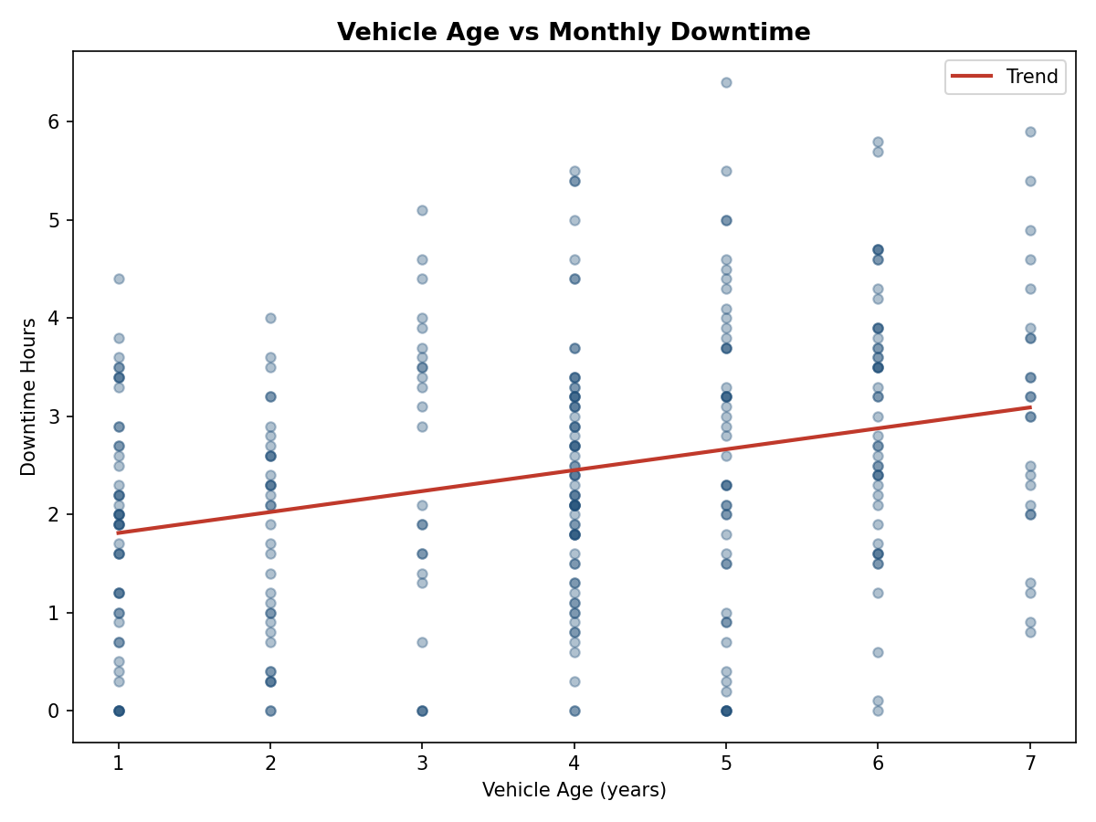
Average Downtime by Vehicle Type
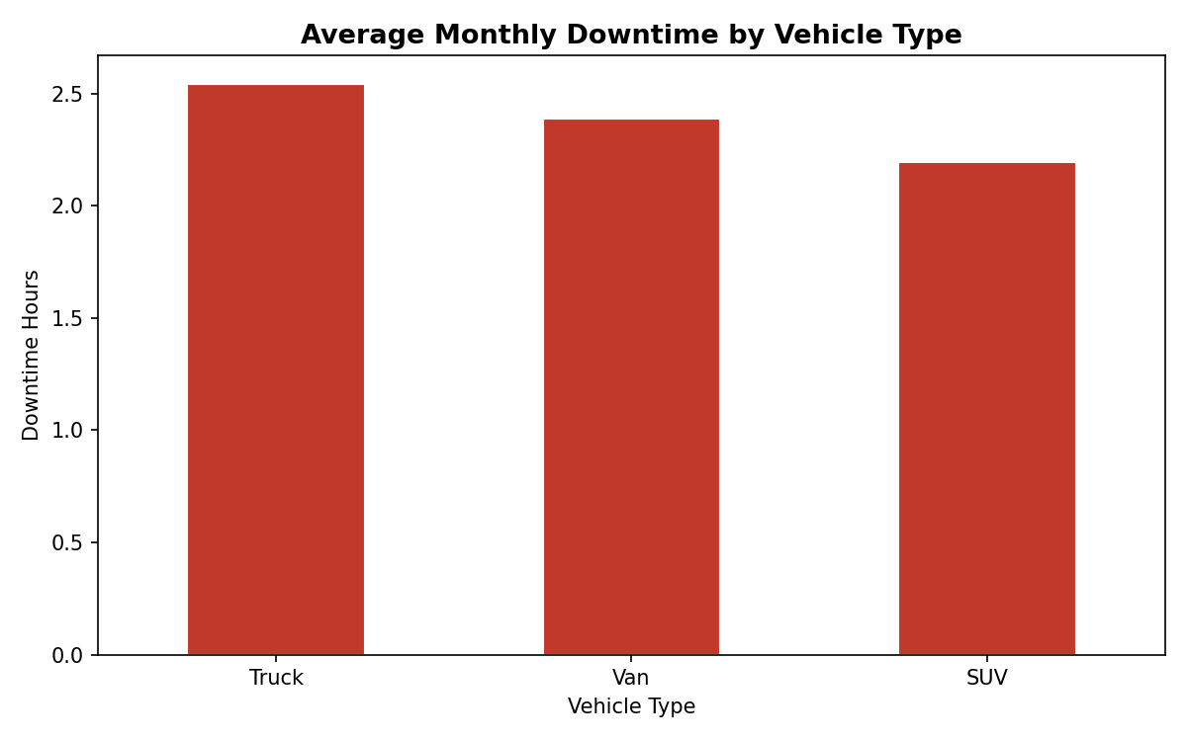
Top 10 Vehicles by Predicted Downtime Risk (Next Month)
Ranked by the model's predicted probability of a high-downtime month. These are the vehicles worth a proactive inspection before the next maintenance cycle, not after a breakdown.
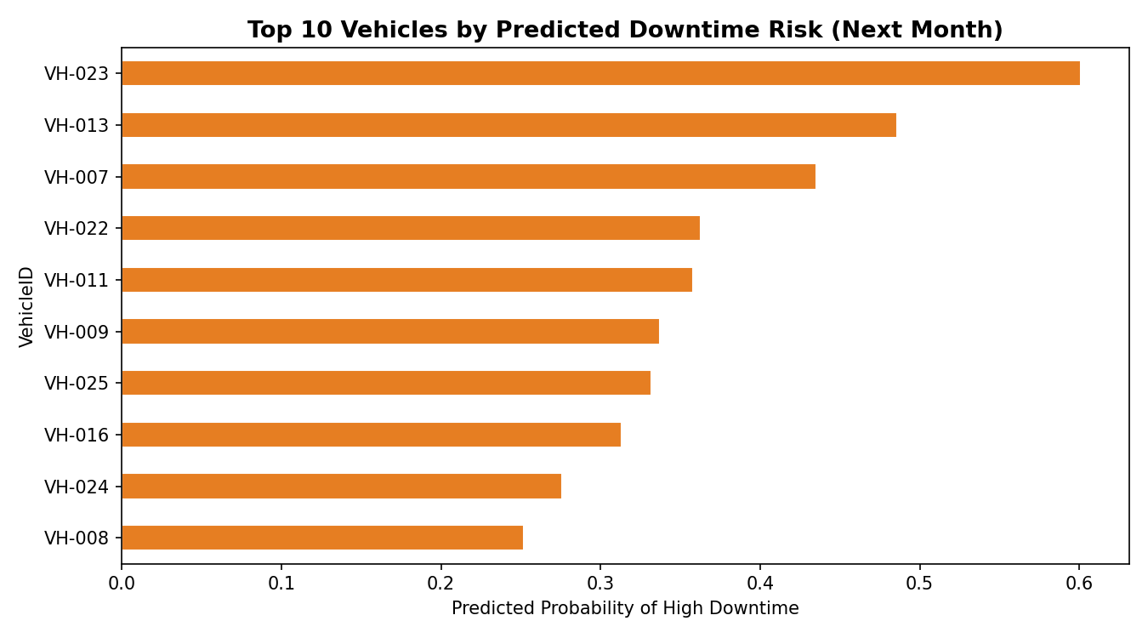
VehicleID | VehicleType | Depot | VehicleAge | OverspeedRate | FuelEfficiency | DowntimeRiskScore
VH-023 | Truck | Abuja Depot | 7 | 0.286 | 3.684 | 0.601
VH-013 | Truck | Kano Depot | 7 | 0.211 | 4.199 | 0.486
VH-007 | Van | Ibadan Depot | 6 | 0.188 | 6.123 | 0.435
VH-022 | Truck | Kano Depot | 5 | 0.133 | 4.272 | 0.363
VH-011 | Van | Lagos Depot | 6 | 0.222 | 7.079 | 0.358
Recommendations
- Schedule proactive inspections for the top 5 vehicles on the risk list this month, prioritizing the two 7-year-old trucks (VH-023, VH-013) — both combine the two strongest risk factors (age and overspeeding).
- Set a fleet-wide replacement review trigger at 6 years of age for trucks specifically, given they carry both the highest downtime and the steepest age-related cost increase.
- Address overspeeding directly through driver coaching rather than only vehicle maintenance — it's an independent, addressable risk factor, not just a symptom of vehicle condition.
- Re-run this model monthly as new data arrives. An AUC of 0.64 with 8 months of data will likely improve as the training set grows — this is a starting point, not a finished system.
Methodology Note (for technical review)
Data pipeline: vehicle and monthly trip/maintenance data stored in SQL Server (FleetOpsIntelligence database) — see 01_schema.sql. Python (pandas, scikit-learn) performed feature engineering (vehicle age, overspeed rate, fuel efficiency) and trained a logistic regression classifier to predict next-month high-downtime risk (defined as downtime above the fleet's 75th percentile). Model evaluated via train/test split with AUC-ROC. Full code in predictive_analysis.py. Dashboard layer (Power BI) connects to the same SQL Server database for live refresh — see the Power BI build guide.

